Page 1: Launch an EC2 Instance
Topic: AWS EC2 instance creation using the Ubuntu AMI
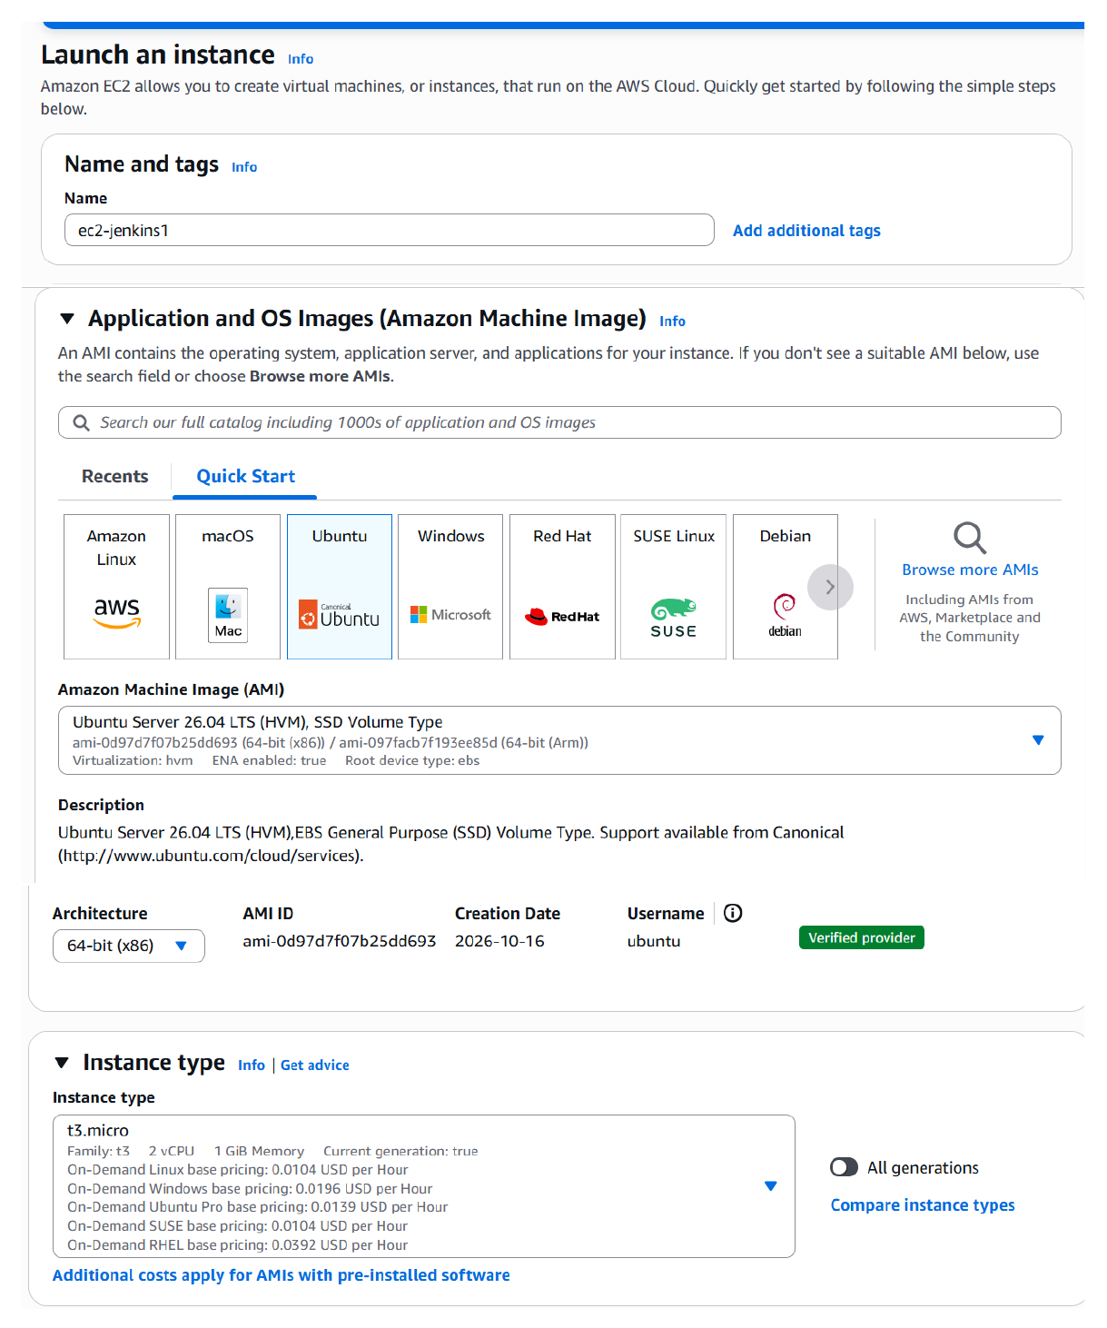
Action: Opened the EC2 launch workflow, selected the Ubuntu machine image, reviewed the instance type and storage settings, and prepared the instance configuration.

Page 2: Configure the Key Pair and Network Settings
Topic: SSH key-pair selection, VPC, subnet and security-group configuration
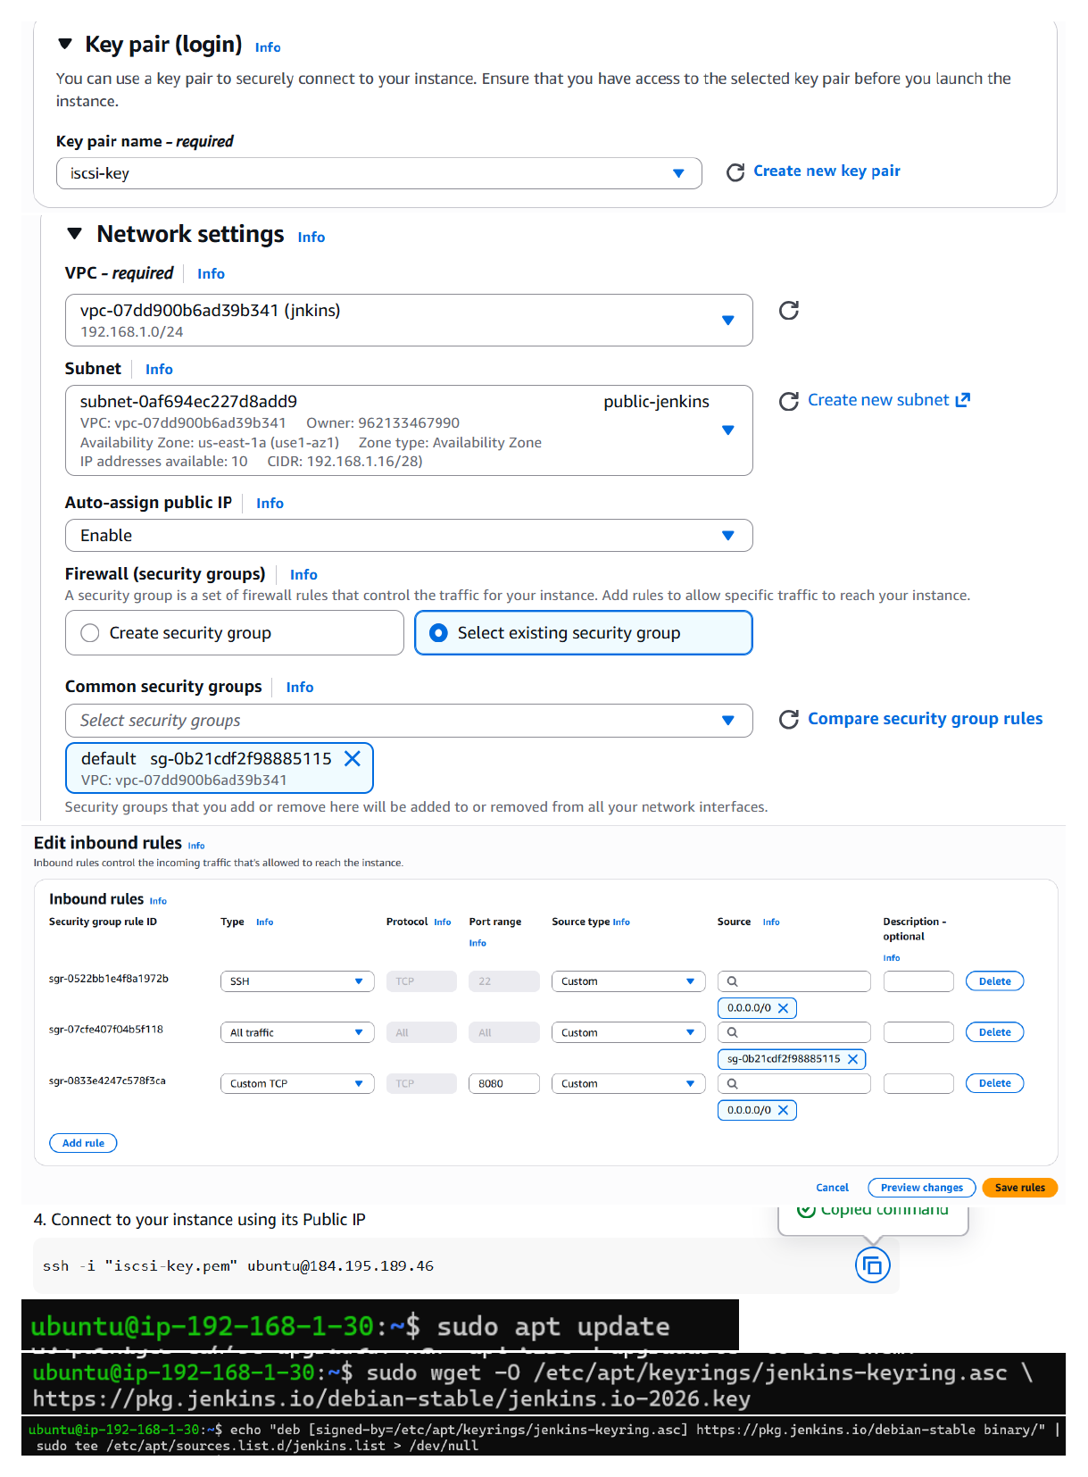
Action: Selected the SSH key pair and configured the instance network settings, including the VPC/subnet and inbound access rules needed to connect to the Ubuntu EC2 instance.

Page 3: Install Jenkins and Retrieve the Initial Admin Password
Topic: Java installation, Jenkins service startup and first-time unlock
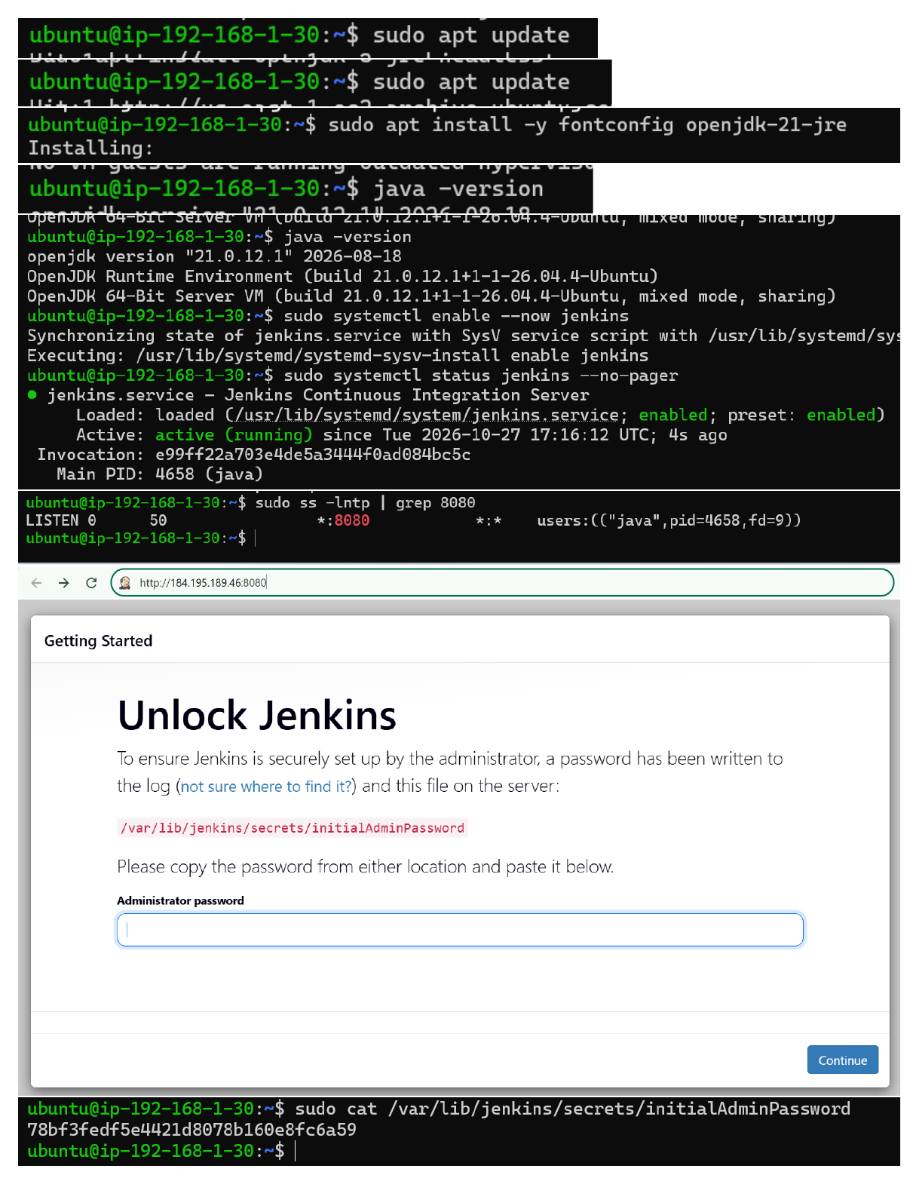
Action: Updated Ubuntu packages, installed Java (OpenJDK 21) and Jenkins, enabled and checked the Jenkins service, verified port 8080, then read `/var/lib/jenkins/secrets/initialAdminPassword` to unlock Jenkins.

Page 4: Create the First Jenkins Administrator
Topic: Jenkins initial setup and administrator account
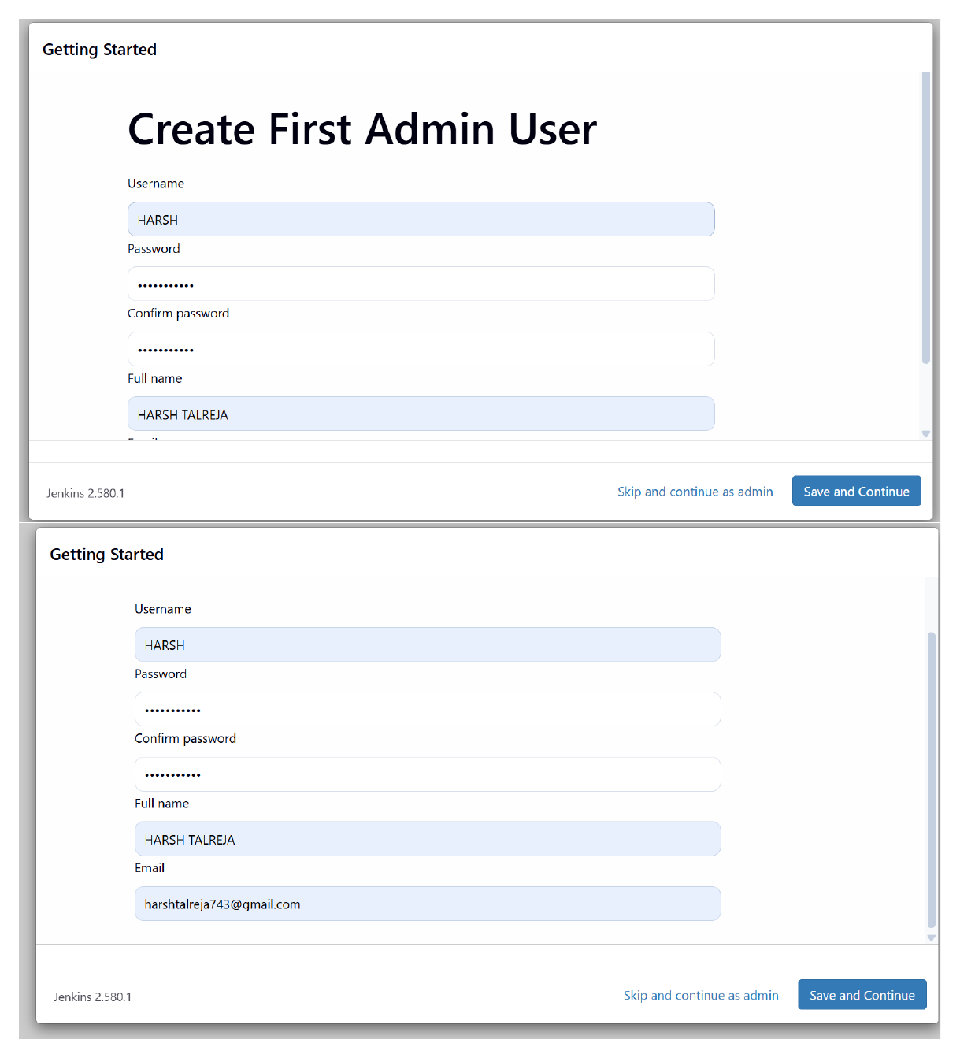
Action: Filled in the Create First Admin User form with the administrator account details and proceeded through the initial Jenkins setup screen.

Page 5: Open Jenkins and Start Creating a Pipeline Job
Topic: Jenkins dashboard and New Item workflow
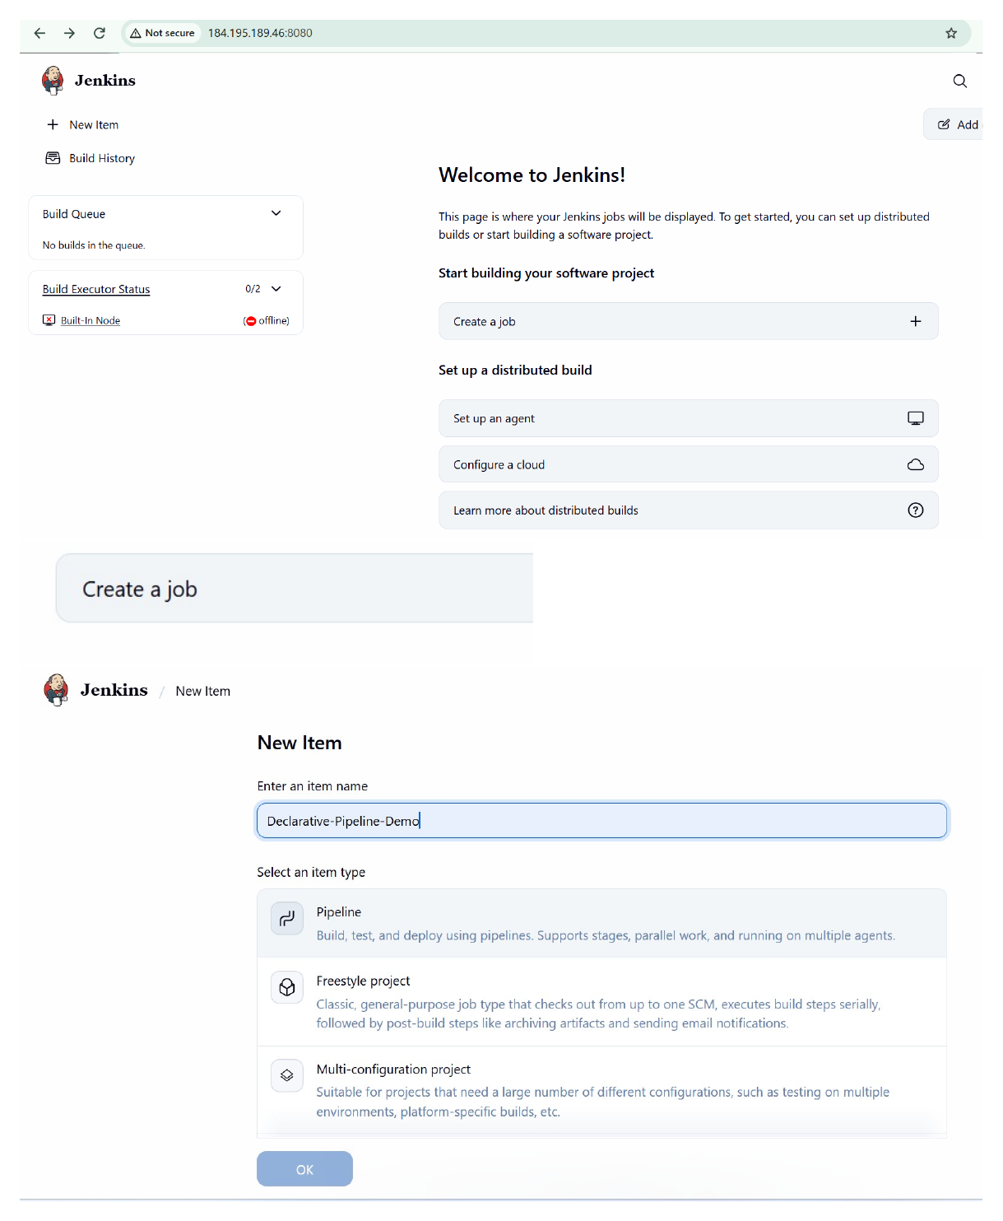
Action: Reached the Jenkins dashboard, opened the New Item workflow, entered the pipeline job name, and began configuring the new job.

Page 6: Select Pipeline Job Type and Add the Script
Topic: Jenkins Pipeline job configuration
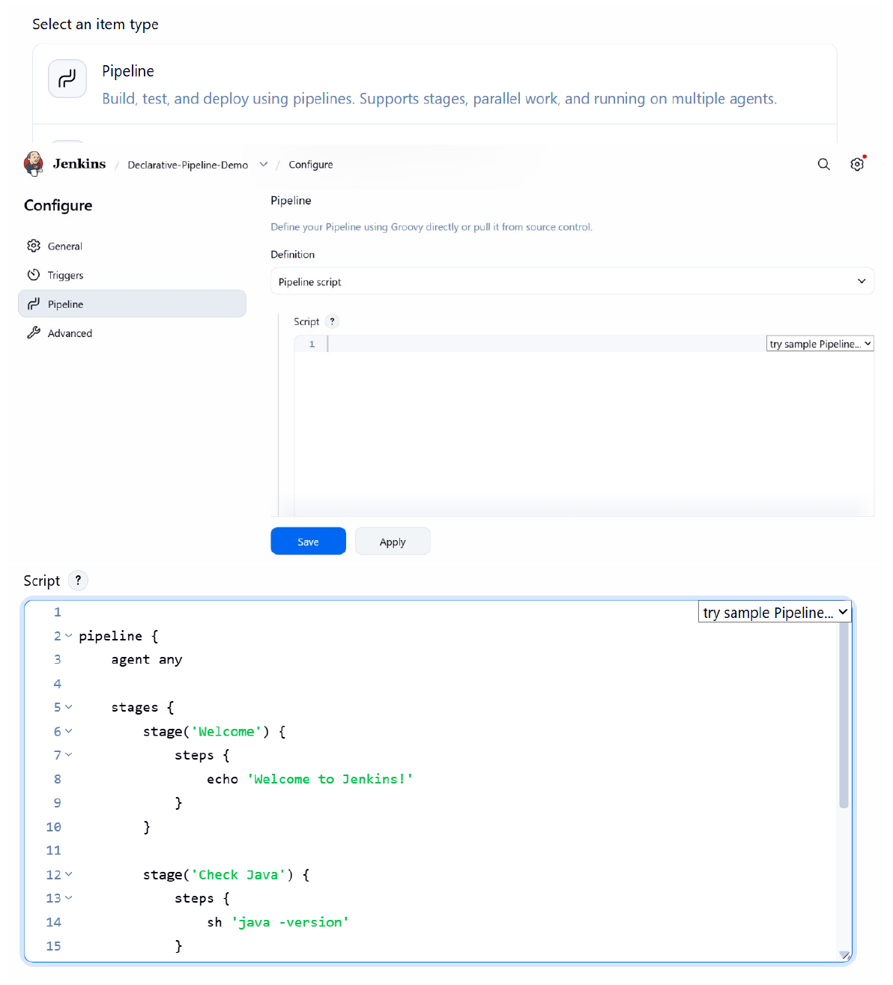
Action: Selected the Pipeline job type and entered a declarative pipeline script in the Pipeline script editor.

Page 7: Review the Declarative Pipeline Stages
Topic: Pipeline syntax with node, stages and stage steps
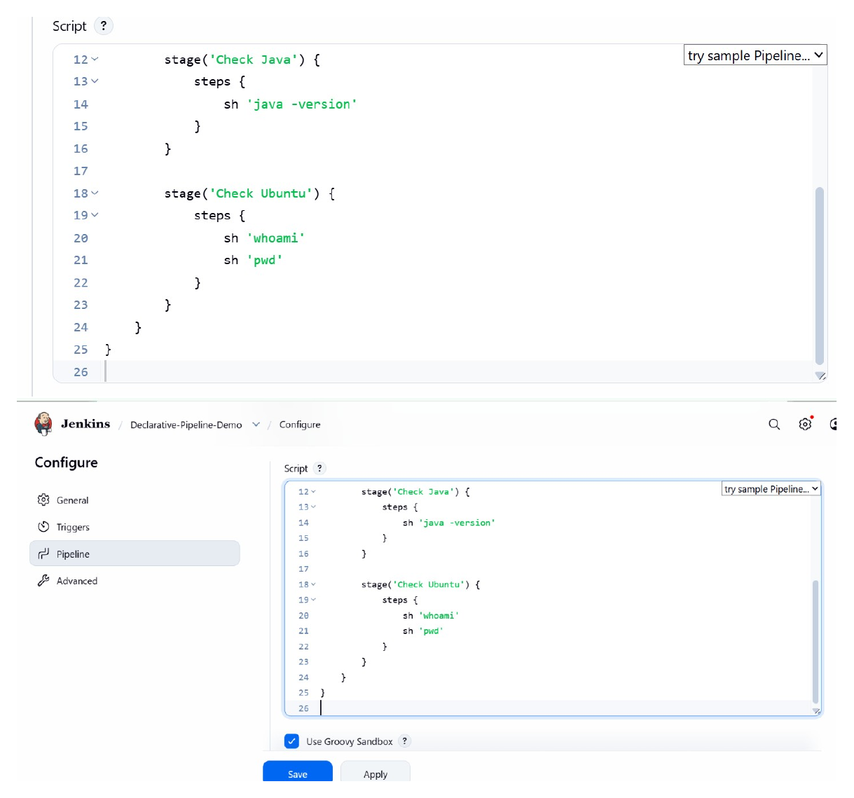
Action: Reviewed the declarative pipeline script, including the pipeline/node structure, stages and step commands, before saving the job configuration.

Page 8: Open the Pipeline Job and Trigger a Build
Topic: Jenkins job dashboard and Build Now
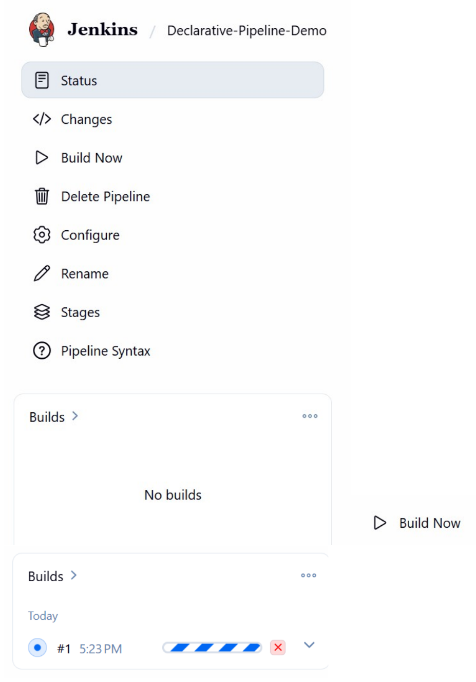
Action: Opened the `Declarative-Pipeline-Demo` job and used Build Now to start a pipeline run; the job page displayed the build activity.

Page 9: View the Jenkins Console and Sign-in Prompt
Topic: Jenkins console access and authentication screen
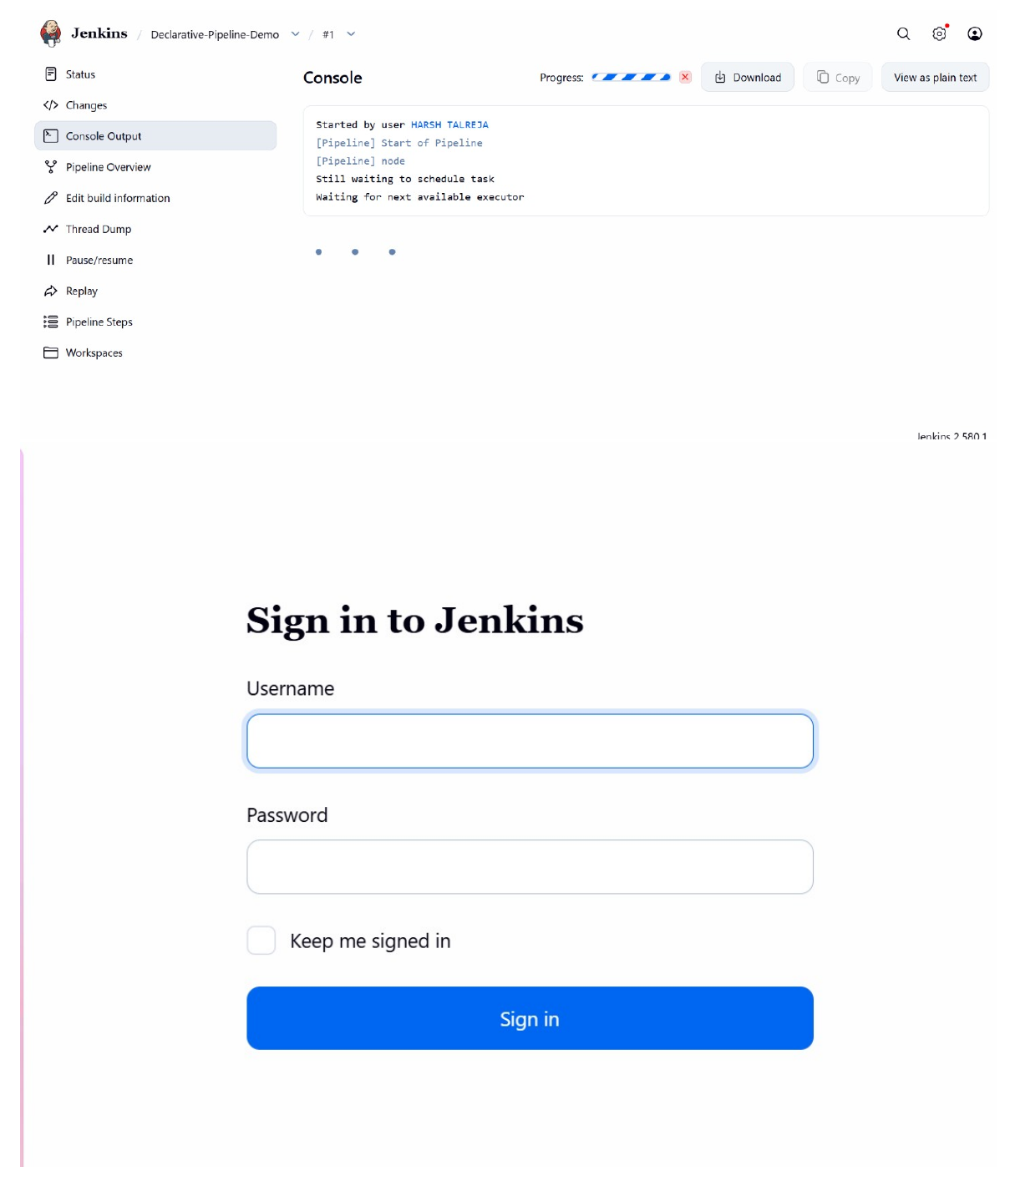
Action: Opened the Jenkins console area and reached the sign-in prompt, where Jenkins requested a username and password before allowing access.

Page 10: Sign In to Jenkins
Topic: Jenkins user authentication
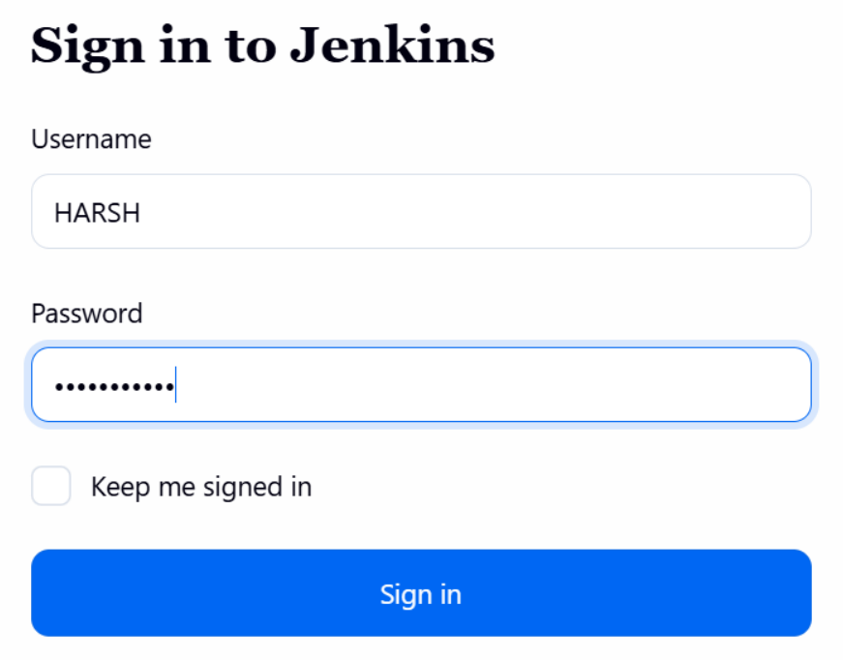
Action: Entered the Jenkins username and password in the sign-in form and submitted the credentials to access the Jenkins interface.

Page 11: Verify the Pipeline Console Output
Topic: Declarative pipeline execution and successful build
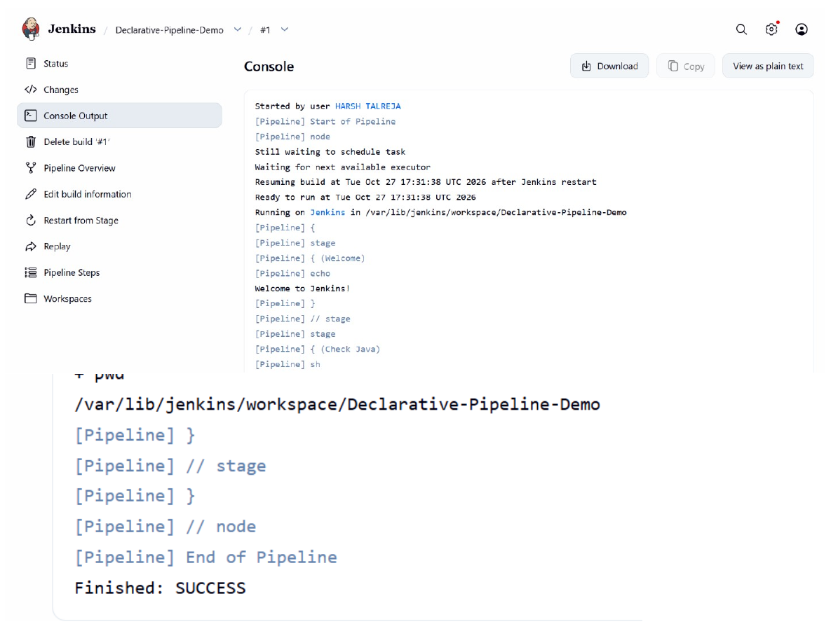
Action: Opened Console Output for build #1 and reviewed the pipeline stages and log messages. The output ended with `Finished: SUCCESS`, confirming that the pipeline completed successfully.

